# Lab Objectives:

1. To become familiar with the basics of Microsoft PowerPoint 2007
2. To become familiar with the basics of good presentation design.

A presentation usually is composed of two elements: the presenter speaking about certain facts and the slides complementing the speech, helping the audience visualize the presented facts.

While there are no universal rules that define a good presentation, the experts point to certain basic principles that can guide presentation design. These basic principles are listed below:

* 1. *Good presentations are simple.*
     1. The presented data is made as simple as possible without compromising the essential information.
     2. The images/ transitions/ animations should add emphasis to the message of the presenter rather than overwhelm it.
  2. *Good presentations are readable by the audience*.
     1. The slides use an appropriately large font size. (Using a large font size also forces you to prioritize your slide’s main points and deleting non-essential information.)
     2. The slides use good contrast between slide background and text. (The color chosen for the text should contrast with the background; on a light background, a dark color should be used and vice-versa.)
     3. They use sans-serif fonts. Read here about what is a sans-serif font and what are serif-fonts.
  3. *Good presentations are visual.*
     1. The slides should complement what the presenter is saying.
     2. A good technique is to use visual content (images/ graphs/ charts/ animations/ movies) to demonstrate the presented idea/ facts. (Some ways to find good quality images online may be seen by visiting <http://tiny.cc/powerpoint>)
  4. *Good presentations are organized*
     1. The slides should flow in a coherent manner and not be disjointed. (To have a constant theme flowing throughout your slides, it’s important that you properly plan your slides; it’s often best to do that on paper rather than on the PC.)
     2. The slides should have an introduction and a summary slide to help the audience in anticipating and recalling the main content of the presentation.

# Lab exercise:

**Starting a presentation:**

Open a new PowerPoint (PPT) presentation. Choose a totally white background. Save the file on the desktop and name it as `your-name’.pptx.

*Hint: The functionality to open and save a new file is available by clicking on the Microsoft Office button Office Button*

# Part I---Inserting and formatting objects:

1. **Inserting text box and text-formatting:**
   1. **Inserting a text box.** On slide number 1, insert a textbox. The textbox is inserted by clicking on the

*Insert* tab and then choosing *Text Box* option in the *Links* tab (as shown in the figure below).

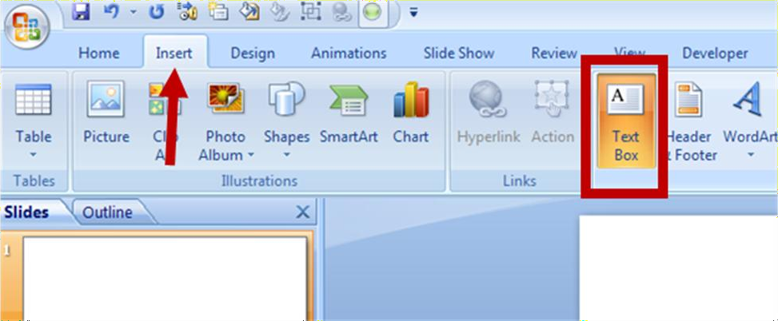

Add the text “Fundamentals of ICT lab” in the inserted text box. Your slide 1 should look like the following.

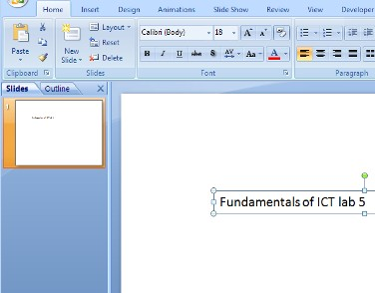

* 1. **Increasing the font size.** Duplicate this slide (slide number 1) by right-clicking on slide 1 (as shown

in the slide sorter on the left hand side of the screen) and selecting duplicate slide. Slide duplication can also be done through copying the slide and then pasting it.

*On slide 2*, increase the font size to 66. This can be done either manually or by clicking on the button shown below. Your slide 2 should look like the following.

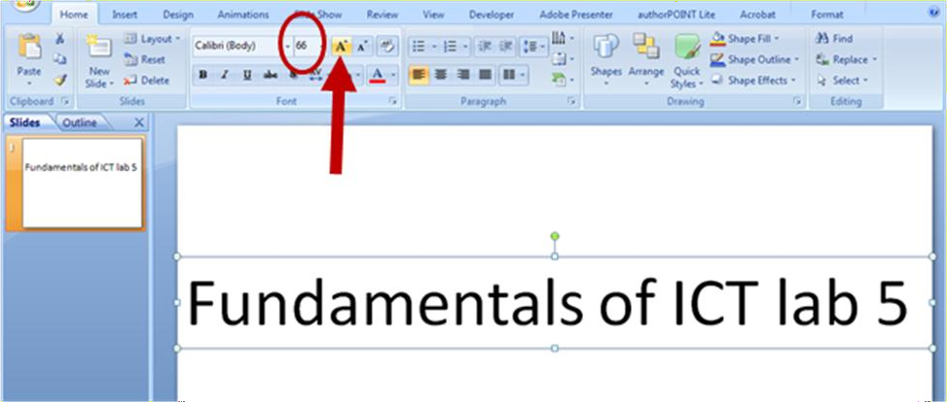

* 1. **Changing font.** Duplicate the previous slide (slide 2) to slides 3 and 4.

*On slide 3*, change the font (which is Calibri by default) to Tahoma. The font may be changed in the field highlighted in the figure below.

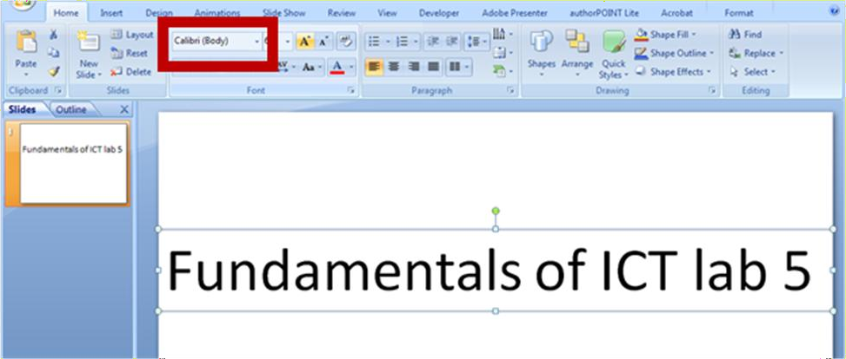

Also, decrease the font size such that the inserted text spans one line only.

* 1. **Changing the fill color of the text box.** Go to slide 4 now.

*On slide 4*, select the text box and then open the Format tab as shown in the figure below. You should be able to see Shape Fill option. Choose light gray color as the background of the textbox. Slide 4 should like the following.

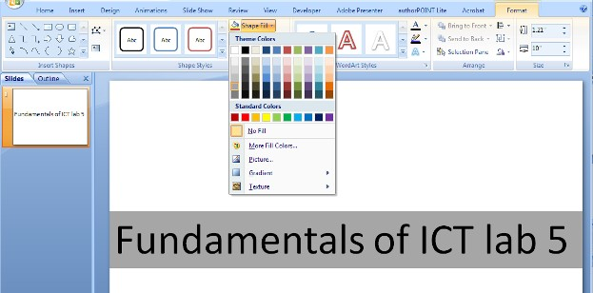

* 1. **Changing text color.** Duplicate the slide 4 on slide 5.

*On slide 5*, select the text box and choose the format tab as shown below. In the format tab, select the text fill option as also shown below. You can choose the color of text by selecting any color here. Choose the color red for the text. Your slide 5 should look like the following.

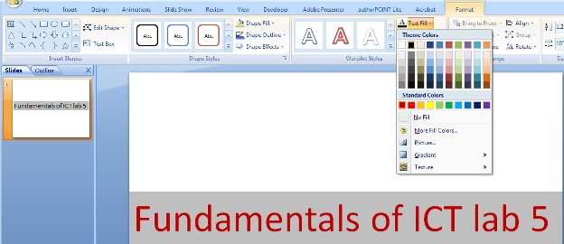

* 1. **Special text effects.** Duplicate the slide 5 on slide 6.

*On slide 6,* select the text box, and then choose the Format tab. On the format tab choose the Text effects option. You will get various text effects options as shown in the figure below. Choose the glow option to add pink glow around the red text. Your slide 6 should look like the following.

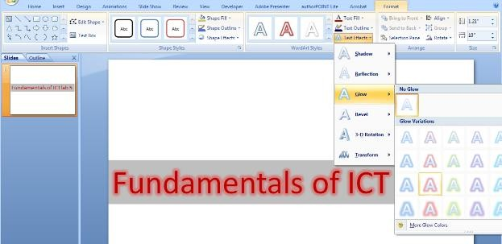

* 1. **Using the Quick Style option.** Duplicate slide 2 on slide 7.

*On slide 7,* select the text box and choose the Quick Style option on the Home tab. You should see many options as shown in the figure below. Choose the style where white text is written on a dark background as shown below. Your slide 7 should look like the following.

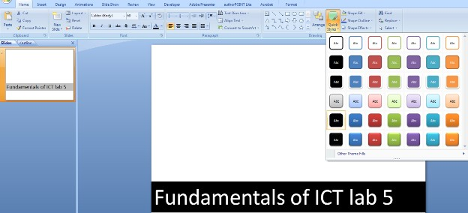

* 1. **Using the Smart Art feature.** Copy the slide 5 on slide 8.

*On slide 8,* replace the text “Fundamentals of ICT lab 5” with a heading “Microsoft Office” followed by an indented list of three items: 1) Word 2007; 2) Excel 2007 and 3) PowerPoint 2007. Your slide 8 should look like the following.

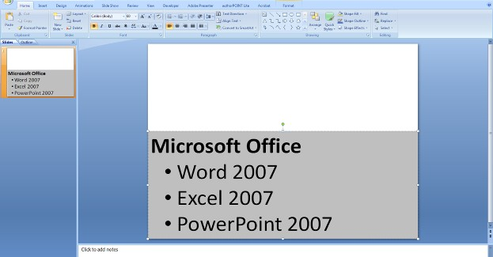

Duplicate the slide 8 on slide 9.

*On slide 9*, choose the Convert to Smart Art option in the Home tab as shown in the figure below.

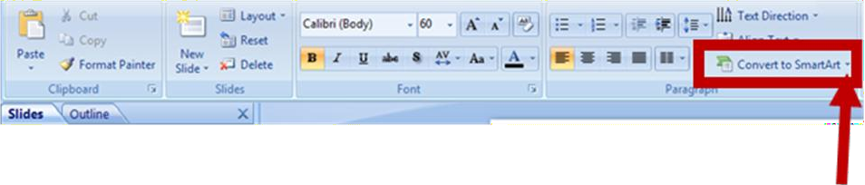

From the Smart Art options, choose the hierarchical organizational graph. Your slide 9 should look like the following.

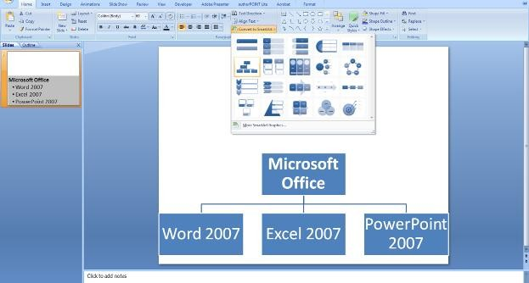

1. **Inserting shapes:**
   1. **Inserting a star symbol.** Insert a blank slide on slide 10. To insert a shape, choose the Insert tab and then choose the shapes option as shown in the figure below.

*On slide 10*, choose the star symbol as shown in the figure below. The fill color of the star should be blue. (Choose shape fill in the format tab if you need to change the color of the star.) Your slide 10 should look like the following:

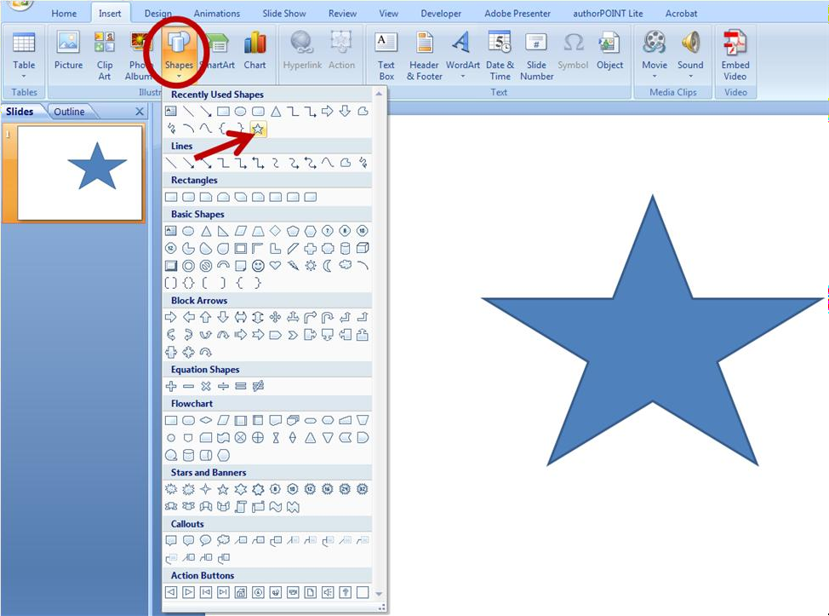

Other symbols can also be added similarly if required.

* 1. **Modifying the star symbol added.** Duplicate the slide 10 on slide 11.

To modify the star symbol just added, choose the Format tab, and then select Edit Shape. Thereafter, choose Convert to Freedom option as shown in the figure below.

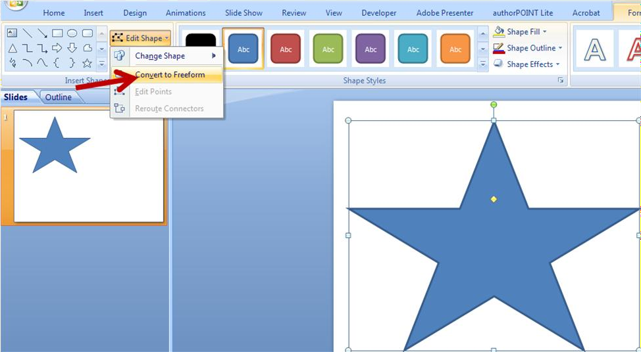

Once the figure has been converted to freeform, its points may be edited and modified. This can be done by selecting the Edit Points options in the Edit Shape menu (shown in the following figure).

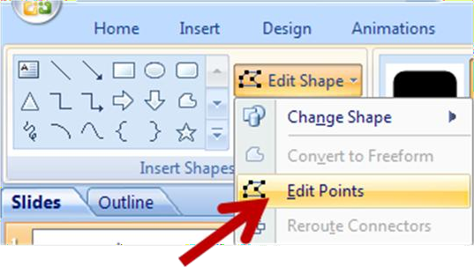

Once the Edit Points option is selected, the points become visible and editable. The points can now be modified. Stretch the points of the star symbol such that it resembles the symbol shown in the figure below. Your slide 11 should look like the following.



# Inserting/ editing and formatting pictures:

* 1. **Inserting a picture.** Insert a blank slide on slide 12. We will add a picture on this slide. To add a picture, the Insert tab must be selected and then Picture must be selected as shown in the figure below.

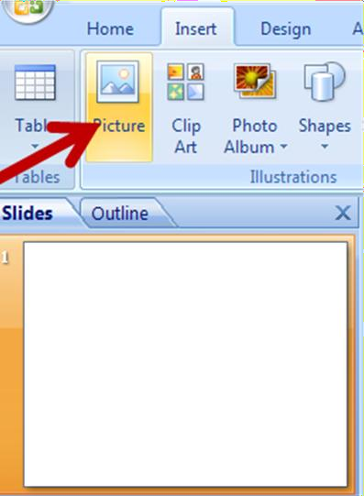

*On slide 12*, Go to Insert -> pictures -> online pictures-> type question

Select the first option available as the following figure



The slide 12 should contain the figure above.

* 1. **Recoloring the image.** Duplicate the slide 12 on slides 13

*On slide 13*, choose the Format option available in the Picture tools (as shown in the figure below). Choose the color option (as shown in the figure below) to see the recoloring options. Choose the

pink color under the Dark Variation options.

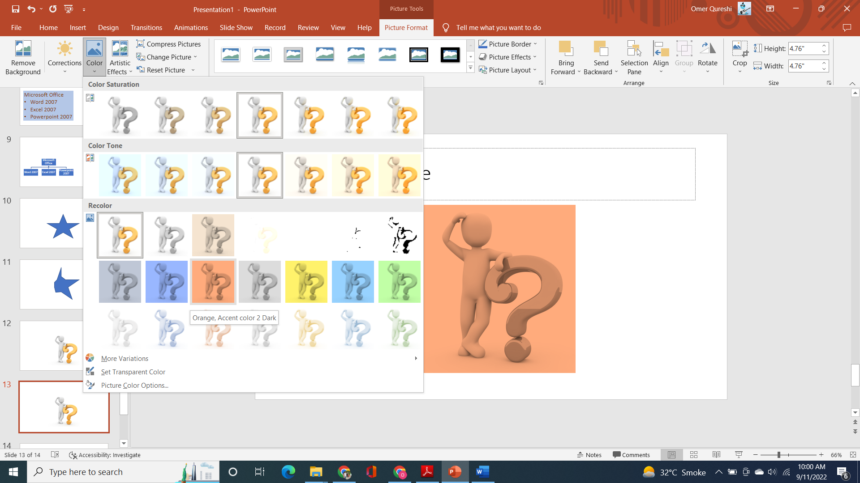

Your slide 13 should look the figure above.

# Setting transparent color in a picture.

*Duplicate slide 13 to 14*, choose the Format option available in the Picture tools (as in the previous question step). We will use the recolor option menu to set transparent the background on the image in the slide. This will be done as shown in the following figure.

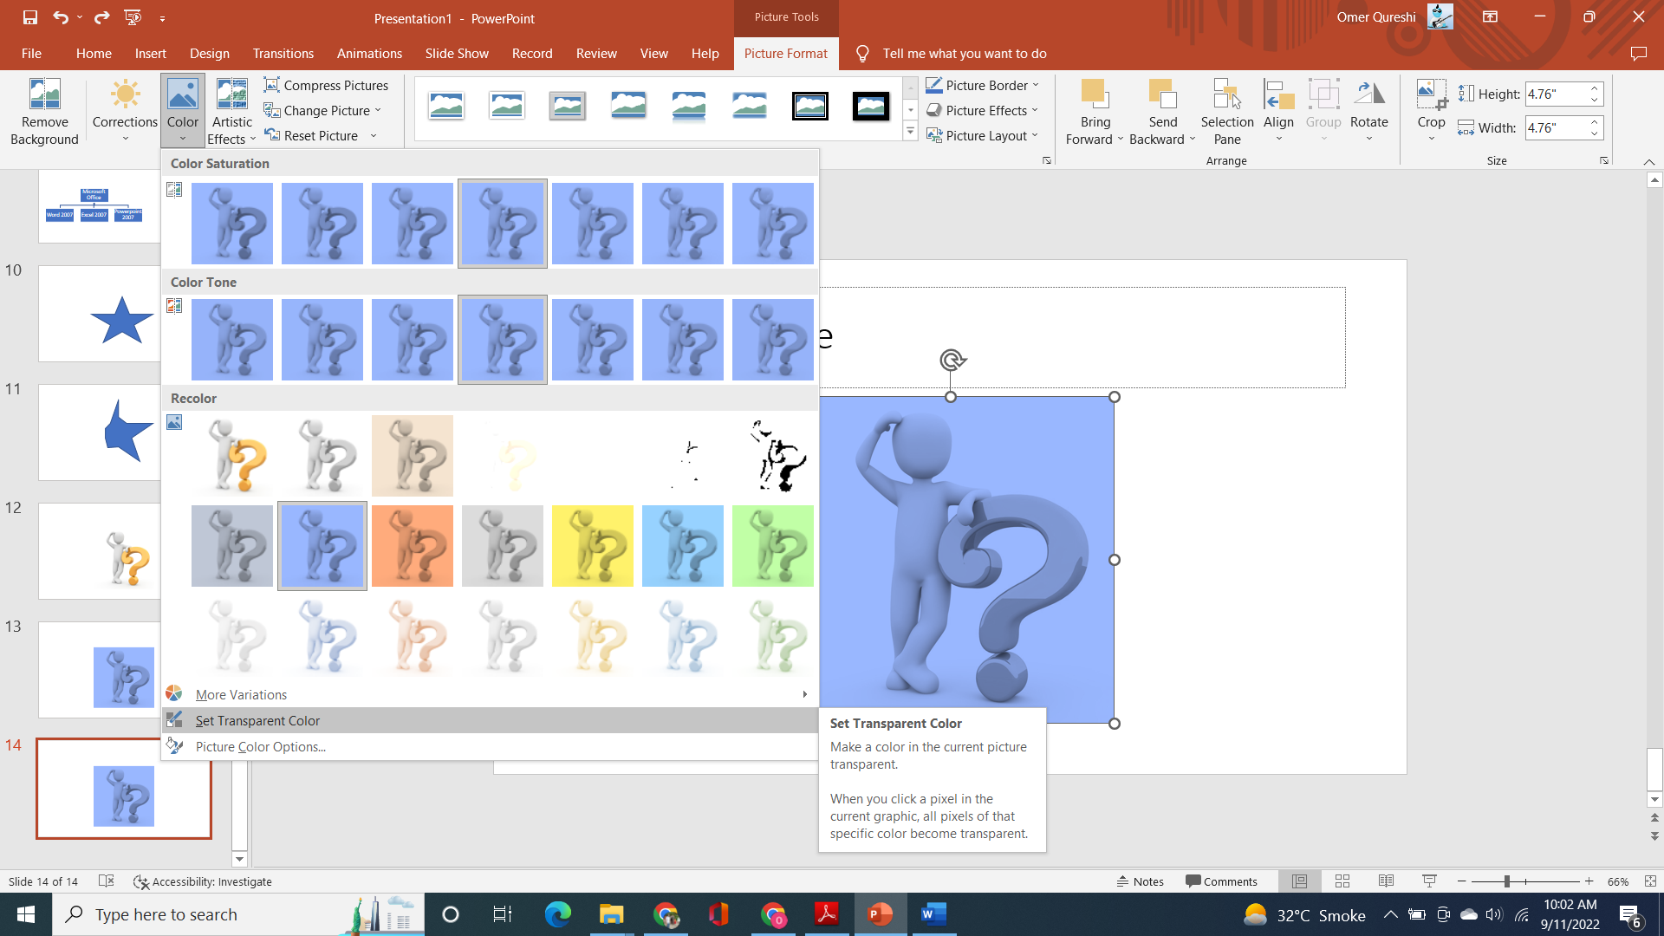

After choosing the “Set transparent color” option, click on the black background of the image. After clicking, the background will be washed away leaving behind the following.

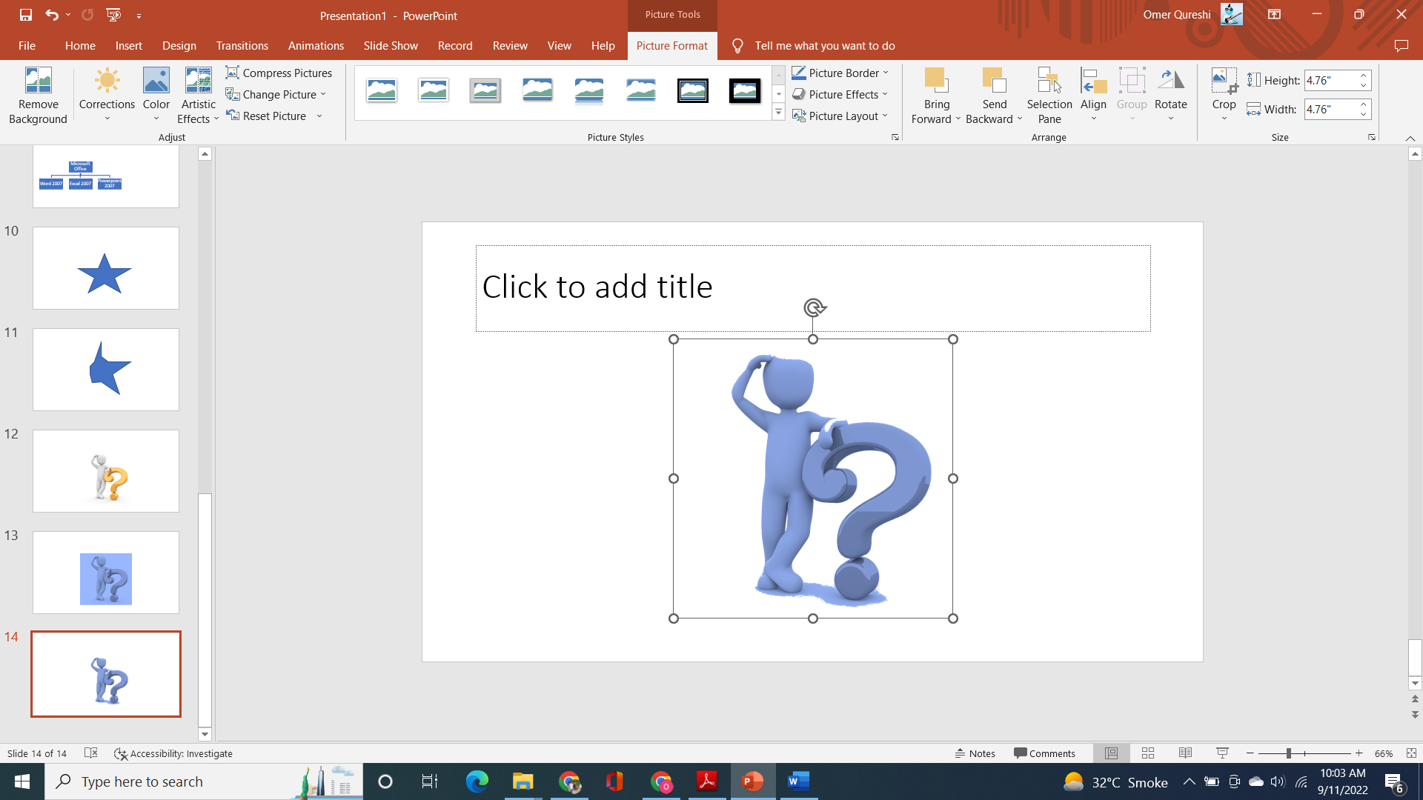

The slide 14 should contain the figure above.

* 1. **Picture Styles.** Duplicate the slide 14 on slides 15, 16, and 17.

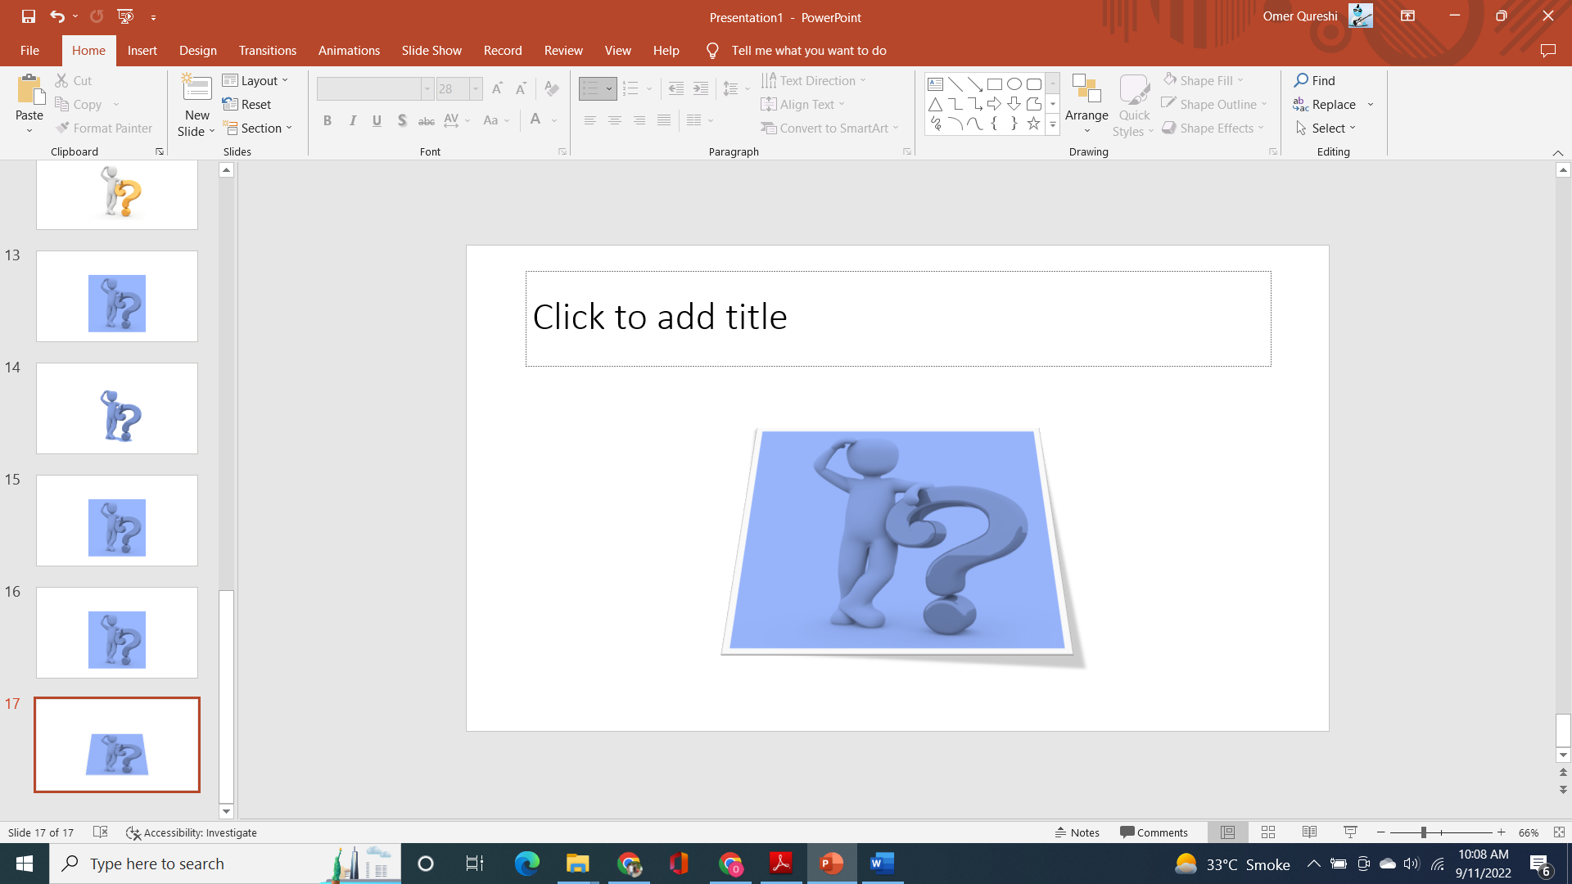

Different picture styles can be chosen by selecting “Format” under the “Picture Tools” tab. Thereafter, “Picture Styles” must be chosen (as shown in the figure above). We can then select from the available picture style options.

*On slide 15,* “Relaxed Perspective White” picture style option must be chosen and displayed (as shown in the figure above)*.* Slide 15 should look like the slide above.

# Picture effects.

Different picture effects can be chosen by selecting “Format” under the “Picture Tools” tab.

Thereafter, “Picture Effects” must be chosen (as shown in the figure below). We can then select from the available picture effect options.

*On slide 16,* the reflection picture effect is to be displayed as shown in the figure below. Choose the “Tight reflection : Touching” variation. The slide 15 should look like the slide below.

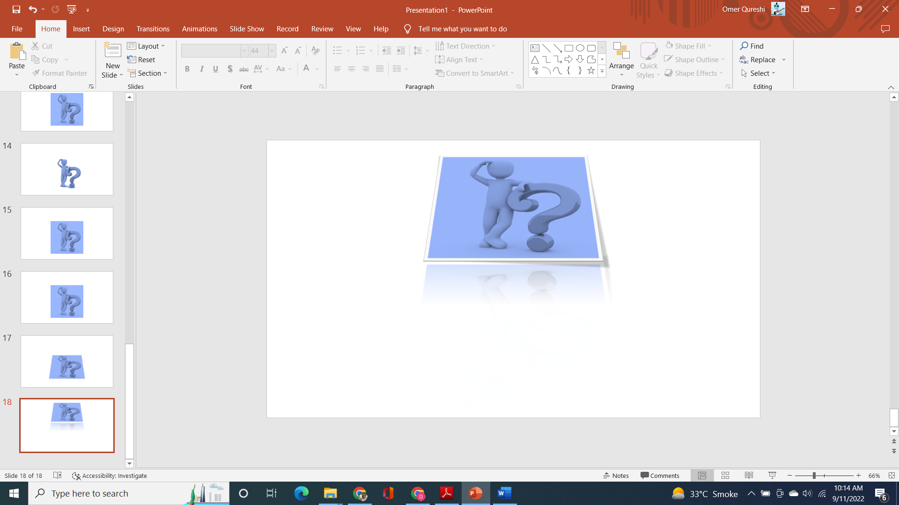

* 1. **Cropping images.** PowerPoint offers the feature of cropping the extraneous part of an image/ picture. Cropping an image can be done by selecting “Format” under the “Picture Tools” tab and

thereafter choosing “Crop” option (as shown in the figure below). After selecting the crop option, the redundant portions of the picture may be clipped away.

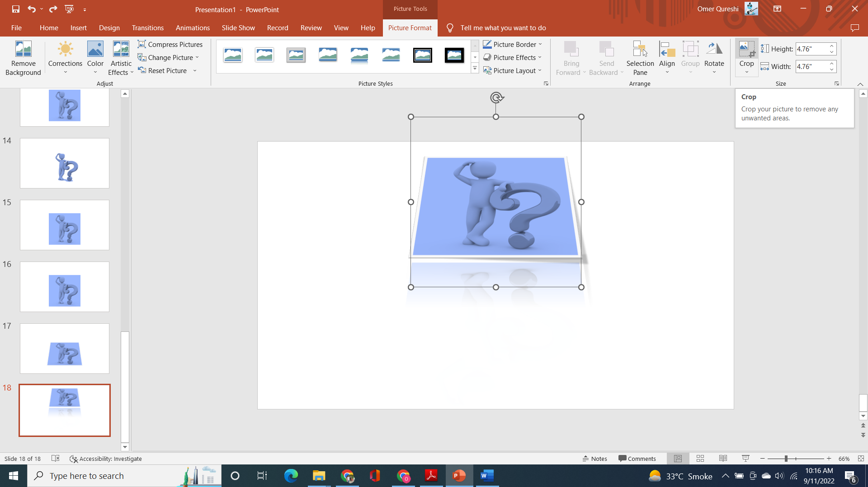

*On slide 17*, we will crop some parts of the question mark image. We will crop the part of the image on the border to produce the image below.

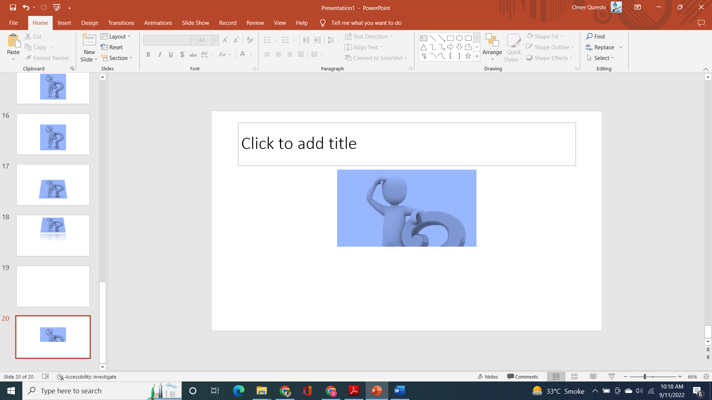

Slide 17 should contain the image above.

# Part II---Formatting background:

* + 1. **Changing the background color (Solid Fill).** Insert a blank slide on slide 18.

The background color of the slide may be changed by right-clicking on the main slide area and then selecting Format Background option. This process is shown in the figure below. There are different options for formatting background (including solid fill, gradient fill, and picture or texture fill).

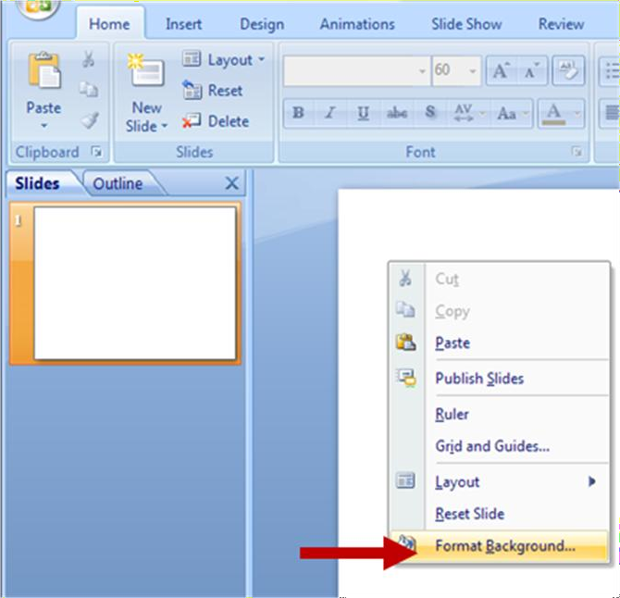

*On slide 18*, we will change the slide’s background color to blue. This will be done by choosing the Solid Fill option in the Format Background menu and choosing the color blue (as shown in the figure below).

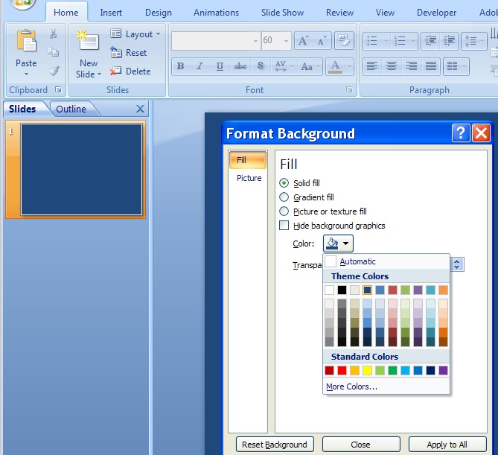

* + 1. **Changing the background color (Gradient Fill).** Insert a blank slide on slide 19.

*On slide 19*, we will change the slide’s background color to a gradient fill of blue. This will be done by choosing the Gradient Fill option in the Format Background menu and choosing the color blue (as shown in the figure below).

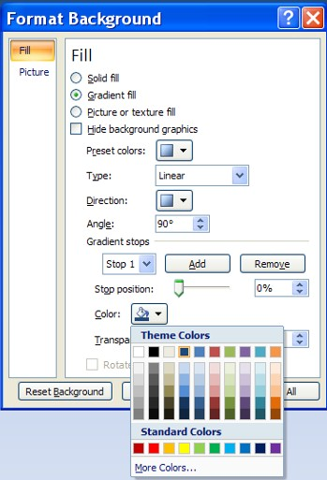

* + 1. **Changing the background color (Picture or texture fill).** Insert a blank slide on slide 20.

*On slide 20*, we will change the slide’s background color to a background from a picture or through a texture file. Select insert and look up a question picture from the internet

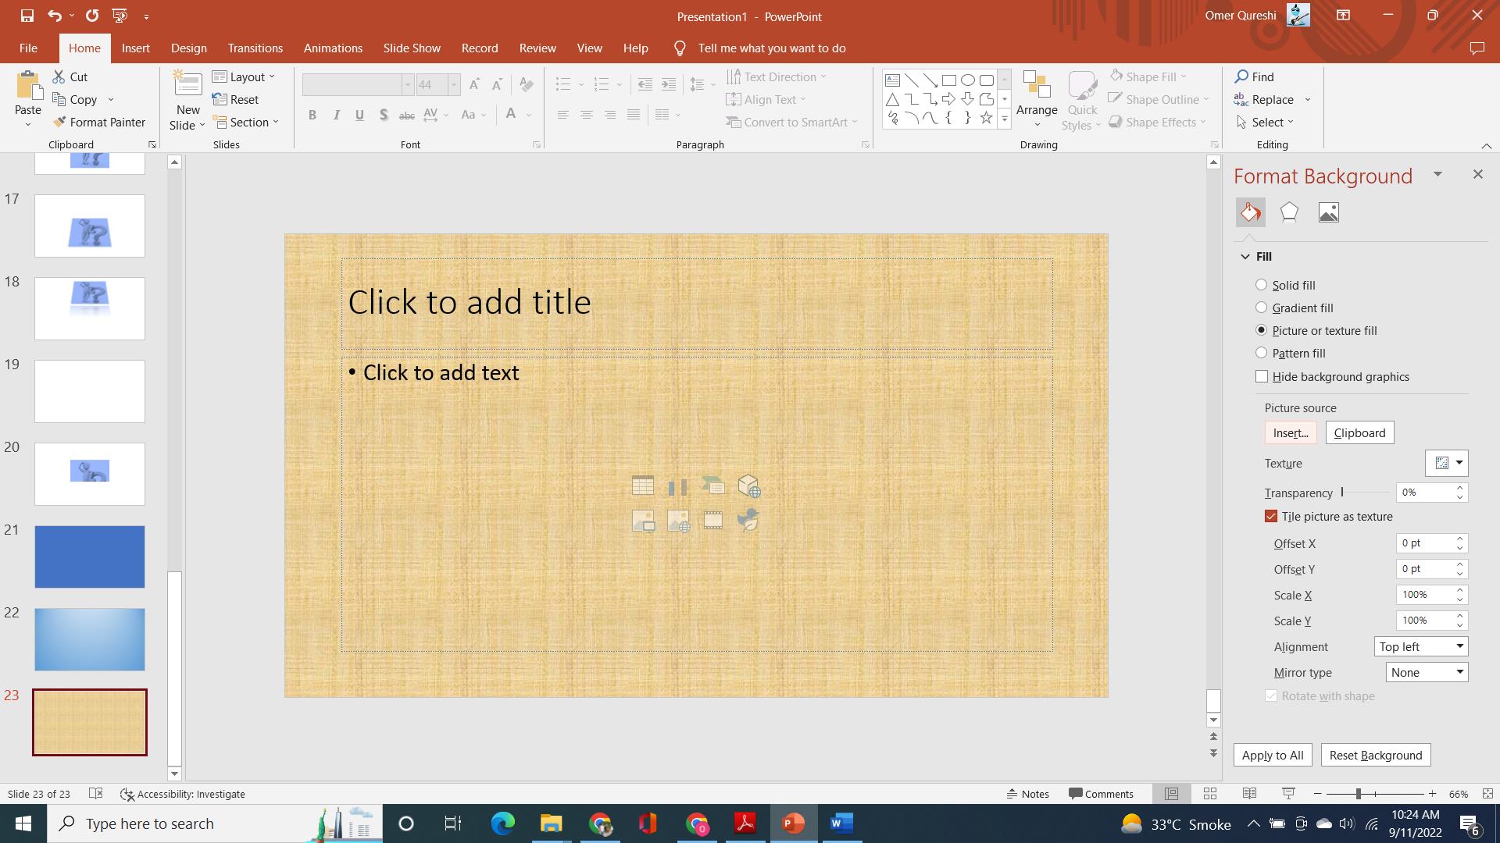

Choose picture of any ball from the internet. Adjust the offsets to ensure the picture fits the screen. Your slide 20 should look like the following

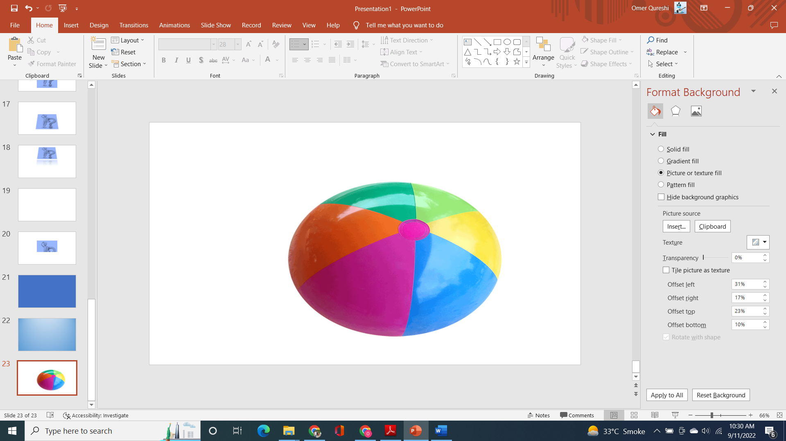

# Part III---Charts and Animations Charts:

**a. Insert a sample chart.** Insert a blank slide on slide 21.

Choose the Insert tab and then the Chart option on the Illustrations tab. There are many kinds of charts available. Choose any kind of a chart and display it on slide 21.

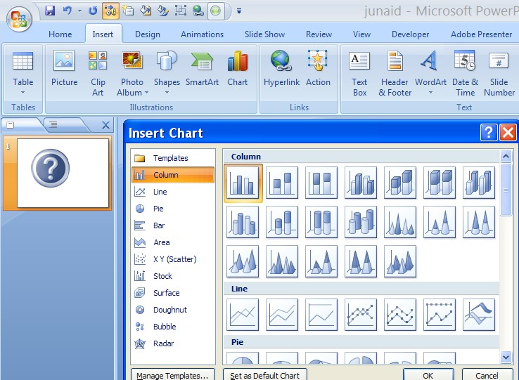

# Animations:

In the simplest sense, animation is something that makes slide objects move on a slide. Slide objects can include text, pictures, charts, SmartArt graphics, shapes, etc. A custom animation can be generated through the add effect button as shown in the figure below.

An animation effect is primarily of four types: entrance effect, exit effect, emphasis effect and motion effect. We will see each one of them separately.

To examine the entrance, exit, emphasis and motion effects, duplicate slide 14 (containing the transparent question mark image) to slides 22, 23, 24 and 25.

# Entrance animation effects in PowerPoint:

*On slide 22*, add the random bars animation effect through the custom animation options (as shown below).

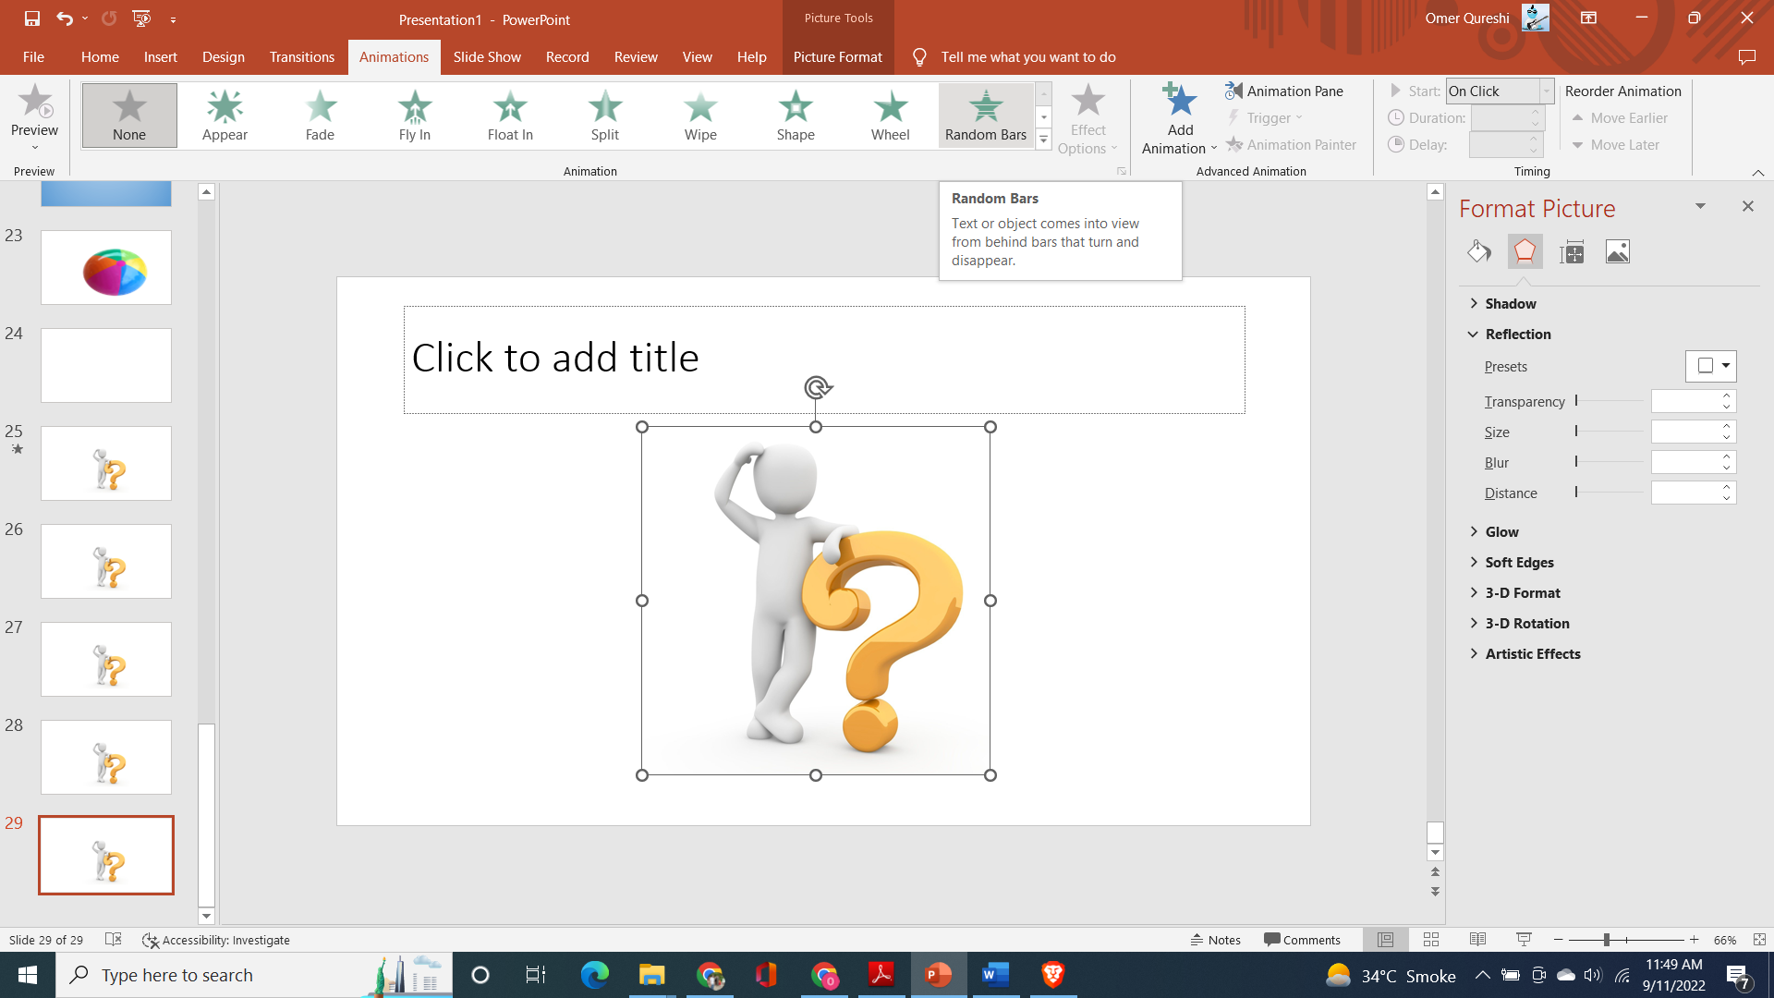

Add animation entrance -> Pulse.

Add animation motion path -> arcs

Add animation exit -> fade